1. Application

   Description automatically generated with medium confidence
2. **Parameterization**:
   1. If we want to repeat a test (means a scenario defined in feature file) multiple times with different Data Set.
   2. Same Step Definition (Method in Step Definition File) will be called for each item in the Data Set.
3. 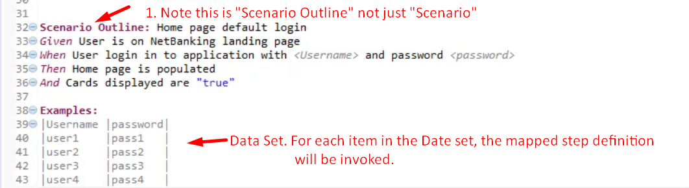  
   Line chart

   Description automatically generated with low confidence  
   NOTE: if Parameter doesn’t match with header, no error but a default value for that parameter will be passed.   
   **For example**:
   1. If you write header “Username” instead of “username” as defined in step, then “<username>” by default will be passed for that parameter in the step definition.
4. Text

   Description automatically generated with medium confidence
5. Graphical user interface, text, application, website

   Description automatically generated